**REDUCTION OF COMMON MODE VOLTAGE USING VARIOUS CARRIER BASED PWM TECHNIQUES**

**A major project report submitted in partial fulfillment of the requirements for the award of the degree of**

**Bachelor of Technology**

***in***

#### Electrical and Electronics Engineering

### ***By***

#### *B.SAI GOWTHAM TEJA (179X1A0208)*

#### *B.SURESH (179X1A0207)*

#### *D.RAMANJINEYULU (189X5A02E3)*

#### *N.LAVANYA (179X1A0269)*

#### Under the Esteemed Guidance of

#### *Dr. M. HARSHAVARDHAN REDDY*

#### *M.Tech., Ph.D*

#### *Associate Professor*

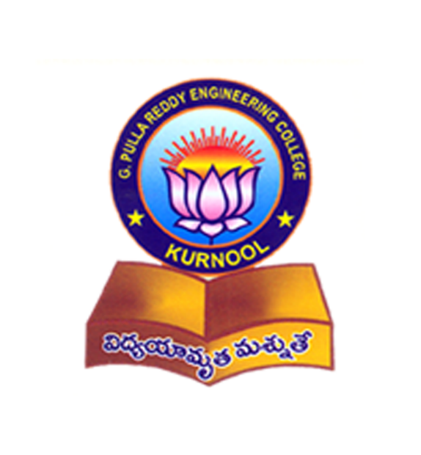

Department of Electrical & Electronics Engineering

G. Pulla Reddy Engineering College (Autonomous): Kurnool

(Affiliated to Jawaharlal Nehru Technological University-Anantapur, Ananthapuramu)

2020-21

Department of Electrical & Electronics Engineering

G. Pulla Reddy Engineering College (Autonomous): Kurnool

(Affiliated to Jawaharlal Nehru Technological University-Anantapur, Ananthapuramu)

##### 

##### 

##### **Certificate**

This is to certify that the project entitled **“REDUCTION OF COMMON MODE VOLTAGES USING VARIOUS CARRIER BASED PWM TECHNIQUES"** is a bonafide work done by **B. Sai Gowtham Teja (179X1A0208), B. Suresh (179X1A0207), D. Ramanjineyulu (189X5A02E3), N. Lavanya (179X1A0269)** in partial fulfillment of the requirements for the award of degree of **Bachelor of Technology** in **Electrical and Electronics Engineering** during the academic year 2020-2021.

The results embodied in this major project have not been submitted to any other University or Institute for the award of any degree.

***Dr. M. HARSHAVARDHAN REDDY***

***M.Tech.,Ph.D***

Associate Professor

E.E.E. Department,

G. Pulla Reddy Engineering

College (Autonomous),

Kurnool, A.P.

***Dr.T.BRAMHANANDA REDDY***

***M.E., Ph.D, MIEEE, MISTE***

Professor & Head,

E.E.E. Department,

G. Pulla Reddy Engineering College (Autonomous),

Kurnool, A.P.

**External Examiner**

**ACKNOWLEDGEMENTS**

We would like to articulate our deep gratitude to our project guide **Dr.M.Harshavardhan Reddy,** Associate Professor, Department of Electrical & Electronics Engineering , G. Pulla Reddy Engineering College, who has always been our motivation for carrying our project. His constant inspiration and effort made this project work great success. We are thankful to him for his contribution in completing this major project.

With a great sense of pleasure, we extend our gratitude to **Dr.T.Bramhananda Reddy** Professor & Head of the Electrical & Electronics Engineering Department , G. Pulla Reddy Engineering College, for his cooperation and providing necessary help for completing this project.

We wish to express our sense of gratitude to **Dr.M.Harshavardhan Reddy**, Project Coordinator, Associate Professor, Department of Electrical & Electronics Engineering , G. Pulla Reddy Engineering College, for providing necessary information to the project batch students regarding project.

We wish to express our sense of gratitude to **Dr.P. Jayarami Reddy**, Director, G. Pulla Reddy Engineering College, for providing necessary facilities.

We wish to express our sense of gratitude to **Dr.B. Sreenivasa Reddy**, Principal,G. Pulla Reddy Engineering College, for providing necessary facilities.

An assemblage of this nature could never have been attempted without reference to and inspiration from the works of others whose details are mentioned in reference section. We acknowledge our indebtedness to all of them. We would like to thanks our parents,faculty of EEE department.

Finally, it is our pleasure to thank our friends for their constructive criticisms, which made us to work hard to produce a better report.

**B.SAIGOWTHAMTEJA(179X1A0208)**

**B.SURESH(179X1A0207)**

**D.RAMANJINEYULU(189X5A02E3)**

**N.LAVANYA(179X1A0269)**